Logic Puzzles & Riddles
The Boxes
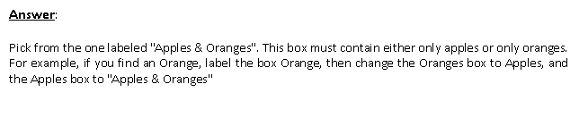
There are three boxes on your teacher’s table. One is labeled "APPLES" another is labeled "ORANGES". The last one is labeled "APPLES AND ORANGES". You know that each is labeled incorrectly. You may ask the teacher to pick one fruit from one box of your choice. How can you label the boxes correctly?

Intuitive Police
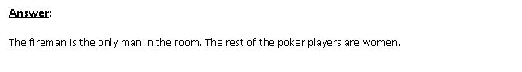
Acting on an anonymous phone call, the police raid a house to arrest a suspected murderer. They don't know what he looks like but they know his name is John and that he is inside the house. The police bust in on a carpenter, a lorry driver, a mechanic and a fireman – all playing poker. Without hesitation or communication of any kind, they immediately arrest the fireman. How do they know they've got their man?

Wise Words
An Arab sheik is old and must will his fortune to one of his two sons. He makes a proposition. His two sons will ride their camels in a race, and whichever camel crosses the finish line LAST will win the fortune for its owner. During the race, the two brothers wander aimlessly for days, neither willing to cross the finish line. In desperation, they ask a wise man for advice. He tells them something; then the brothers leap onto the camels and charge toward the finish line. What did the wise man say?

Hair Color
You are driving a bus. At the first stop, 2 women get on. The second stop, 3 men get on and 1 woman gets off. Third stop, 3 kids and their mom get on, and a man gets off. The bus is grey, and it is raining outside. What color is the bus driver’s hair?

Safe and Sound
You are on the bank of a river. You have to get a fox, a hen, and sacks of corn to the other site of the river. If left alone, the fox will eat the hen, the hen will also eat the corn if left alone. The boat is only big enough to take you and one other from among the three to the other side. How do you get all three safely on to the other side?
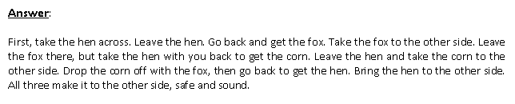

Fortune Telling
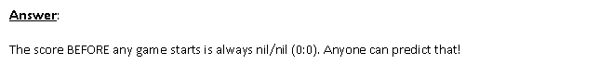
Ahmed does not have any special powers, but he can predict the score of any football game before it begins. How is he able to do this?

Decode the Code
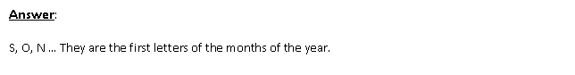
What are the next 3 letters in the following sequence? J, F, M, A, M, J, J, A, __, __, __

Highest Point
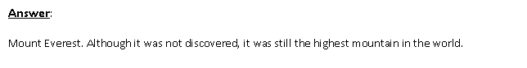
Before Mt. Everest was discovered, what was the highest mountain in the world?

Falling Baby
How could a baby fall out of a twenty-story building onto the ground and still live?

